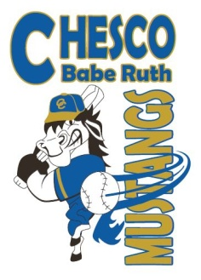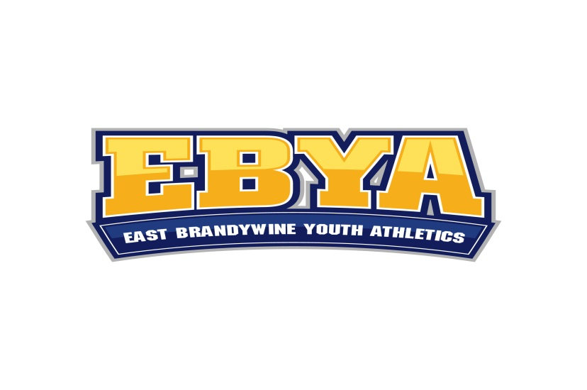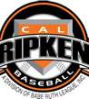

East Brandywine Youth Athletics
www.ebya.org

Dear Community and Business Leader,

East Brandywine Youth Athletics, Inc. (EBYA) is a non-profit organization dedicated to providing boys and girls in Chester County, PA the ability to play organized sports. We are located in East Brandywine Township, just north of Downingtown. Our participation expands beyond Chester County lines. Our facilities are utilized by thousands of family and friends annually.

Since we are a Non-Profit and 100% volunteer organization, we are always searching for and requesting sponsors for our programs. Sponsorship funds help us pay for uniforms, equipment and field maintenance. In addition, we have several capital improvement projects planned for 2015-16 such as new outfield fencing and infield improvement projects. We ask you to consider participating in one or more of the different ways you can help our organization. All your donations are tax deductible and we will provide all backup information required.

EBYA baseball and softball have approximately 450 boys and girls ranging in age from 5-18 participating. Baseball and softball leagues run from early April through October. The EBYA league is part of Babe Ruth/Cal Ripken Baseball.

Your business name on a Field
($1,500 annually-Field B (softball) / Larger 60’ x 90’ Baseball Fields C or D

We have started offering our individual field locations as your address for sales.

Example- Coming this Spring 2015, Chester County Babe Ruth baseball playing at "Your Company Name" field. All advertisements we do to schedule games, events, tournaments would have your name and logo. Official league emails to all participants will have your business name displayed as a supporting sponsor of youth athletics. The Company name will also be displayed on a metal sign on the backstop (3’ x 1’) of the sponsored field. The sponsor is also recognized on the EBYA baseball/softball website

Fields available are the 60’ x 90’ baseball fields C and D and Softball field B at East Brandywine Community Park. Fields C and D are the large professional size baseball fields and attract guests from all over Chester County for Woodbat and Babe Ruth league baseball. Field B is the softball field and also attracts visiting softball teams from Chester County.

Your business name on Softball Field B-Scoreboard ($700 annually/$1,100-2 years)

We are looking for a sponsor for our softball field scoreboard. Your Company name/logo would appear on a sign at the top of the scoreboard (4 feet x 5 feet). Note-We could also accommodate two sponsors, splitting the above sign space at $450 annually/$625-2 years for each sponsor.

Gold Sponsor ($450-1 year/$725-2 years)
-Sponsor name is placed on a team jersey (back). Sponsor receives a team photo plaque.
-Sponsor receives a 5 foot x 3 foot professionally designed and printed vinyl sign promoting
their business/organization.
-Signs are prominently displayed on the outfield fences at the EBYA field complex from
April through October.
-Sponsor is also recognized on a group sign at the field complex and on the
EBYA baseball/softball website.

Silver Sponsor ($250-1 year/$400-2 years)
-Sponsor name is placed on a team jersey (back). Sponsor receives a team photo plaque.
OR
- Sponsor receives a 5 foot x 3 foot professionally designed and printed vinyl sign promoting
their business/organization.
-Signs are prominently displayed on the outfield fences at the EBYA field complex from mid
April through October.
-Sponsor is also recognized on a group sign at the field complex and on the
EBYA baseball/softball website.

Platinum Sponsor –for Larger 60’ x 90’ baseball fields ($600-1 year/$975-2 years)
-Sponsor receives a 8 foot x 4 foot professionally designed and printed vinyl sign promoting
their business/organization.
-Signs are prominently displayed on the outfield fences at the EBYA field complex from mid
April through October.
-Sponsor is also recognized on a group sign at the field complex and on the EBYA
baseball/softball website.

Bronze Sponsor ($150-1 year/$240-2 years)
-Sponsor is recognized on a group sign at the field complex and on the EBYA baseball/softball
website.

Designated Hitter-(great for proud parents and grandparents) ($75-1 year/$120-2 years)
-Sponsor is recognized on a group sign at the field complex and on the EBYA baseball/softball
website.

Please consider the options below and choose the area where you wish to help. No donation is too small and is appreciated very much.

On behalf of the board of directors, coaches, parents and kids of EBYA, we thank you in advance for your consideration and for your generous financial and community support.

Kind Regards,

East Brandywine Youth Athletics
John McMahon
President
______________________________________________________________________________

Contact Names for Sponsorship:

Scott Britt 610-942-9794 brittfamily4@comcast.net
Rob McMichael 610-909-2446 robm1970@icloud.com
Chad Speiser 610-942-4668 chad.speiser@hotmail.com

Mail this completed form and check to:

EBYA Baseball/Softball 203 Montpelier Drive Downingtown. PA 19335
Attn: Frank Gormley, Treasurer
______________________________________________________________________________

Sponsor/Company Name:___________________________ Sponsor Level/Type:____________

1 year option _________ 2 year option_________ Field Choice:_____________

Address: _________________________________

Contact Name: _________________________ Email:_______________ Phone:____________

Contact For Artwork:____________________ Email: ________________Phone:____________

Name Of Any Children In EBYA:__________________________________________________

